**Lab Submission Worksheet**

**Laboratory 3 — Blood Pressure**

Lab Group: Date: October 15th, 2019

Student 1 Student 2

Name: Adam Rocco Name: Josh Hayles

Student Number: 101025114 Student Number: 101031998

Instructions

Step 1 Complete the Lab and take screenshots requested. They will be used to answer the questions.

Step 2 Print and attach the following labeled plots:

1. Figures of the filtered data and then detrended data for each file with labeled systolic, mean arterial and diastolic values. (see figures 2 and 5 in the lab instructions)

Step 3 Write your answer to all questions in the provided boxes.

Step 4 Submit to the drop box for “sysc4203” outside ME4460 before 2:00pm one week after the lab.

**2.0 - Data Collection Step**

a. Open your saved data files in Matlab and plot the filtered data. Find your systolic pressure on this plot. Detrend the data (Appendix B) and determine when the MAP is observed. Correlate the time MAP is observed in the detrended plot to the original recording to determine the pressure value. Calculate the estimated DP using the equation: MAP = 1/3 (SP – DP) + DP. Include figures of the filtered data and the detrended data for each file and label your systolic, mean arterial and diastolic values on both, similar to figures 2 and 5. Fill in those values in the table below. Show your work.

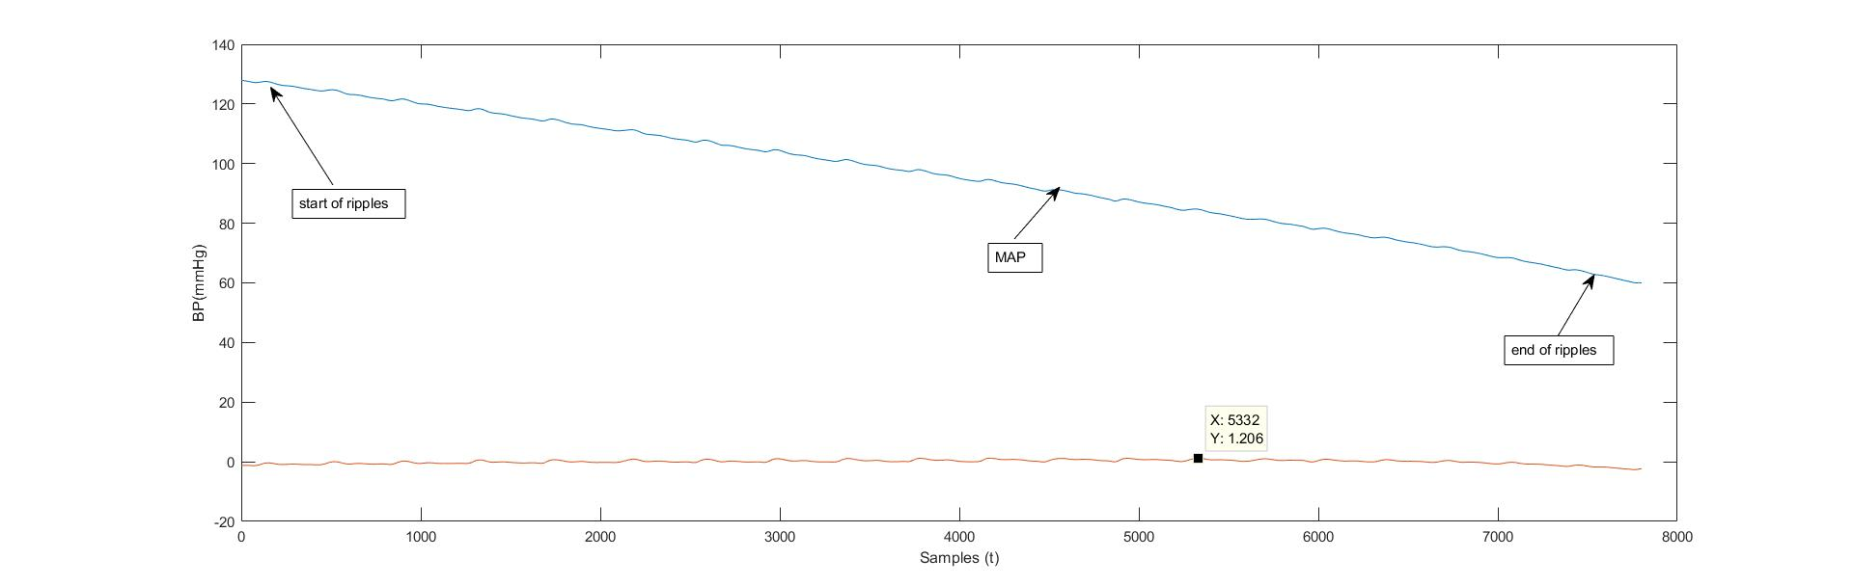

Figure 1. Relaxed 1

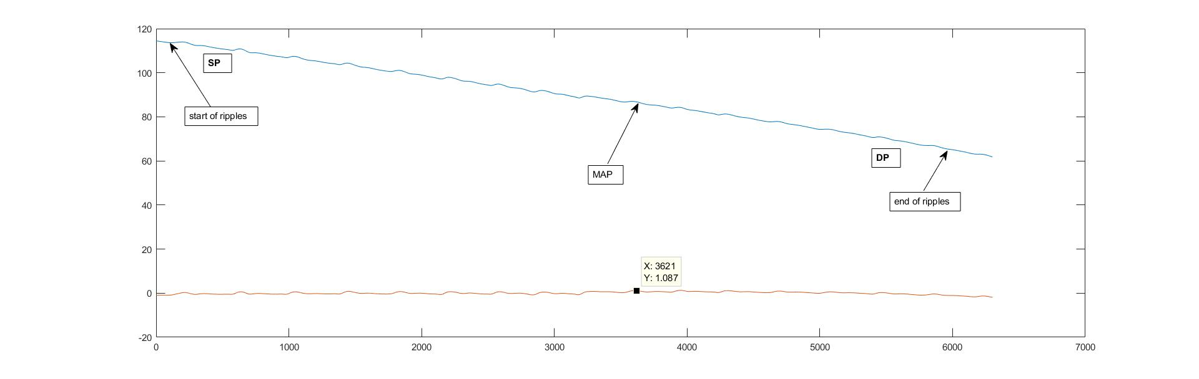

Figure 2. Relaxed 2

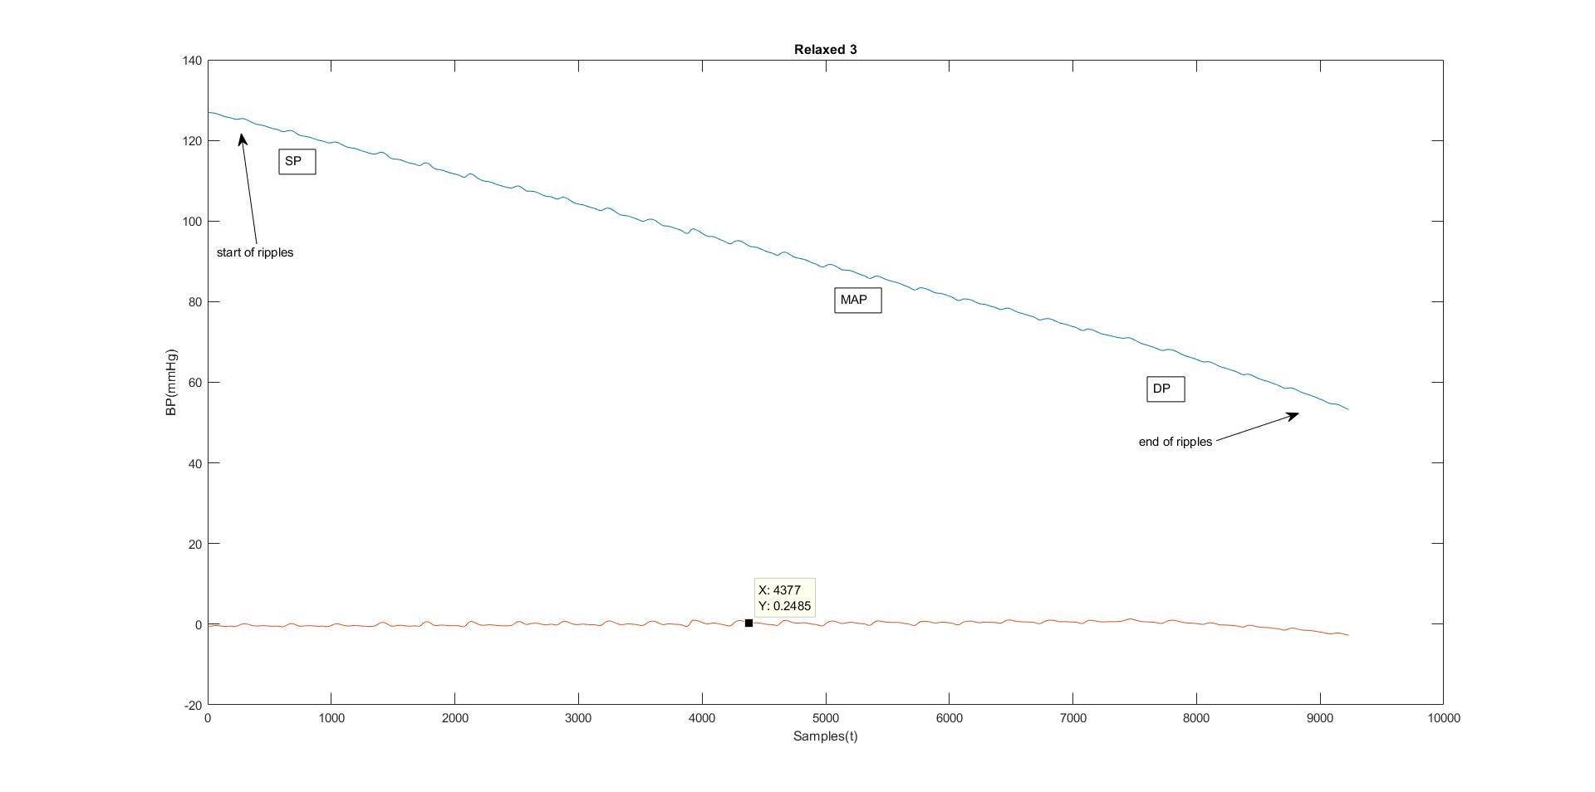Figure 3. Relaxed 3

Table 1. Relaxed Tests

|  | Systolic(mmHg) | MAP(mmHg) | Diastolic(mmHg) |
| --- | --- | --- | --- |
| Trial 1 | 128 | 84 | 62 |
| Trial 2 | 132 | 84 | 60 |
| Trial 3 | 127 | 71 | 43 |
| Average | 129 | 79 | 55 |

b. What is your heart rate (in beats per minute) for each file? (Use the middle 5-10 beats where the ‘ripples’ are)

**See Appendix for example Calculation

Table 2. Average Heart Rate in BPM for the Relaxed Tests

|  | Heart Rate (BPM) |
| --- | --- |
| Trial 1 | 81.87 |
| Trial 2 | 90.61 |
| Trial 3 | 92.79 |
| Average | 88.42 |

c. What was the delay between the heart beat on the ECG and the heart beat on the blood pressure waveform (for each file)? Why would a delay exist? (hint: compare the x-axis values of the QRS peaks with the x-axis values of the ripples during the ‘ripples’ section of your BP signal)

The delay between the heart beat on the ECG and the heart beat on the blood pressure waveform for each file is as follows

Relax 1: 1326-1176=150 => delay 0.3 seconds

Relax 2:1816-1677 = 139 => 0.278 seconds

Relax 3: 2115-1990 = 125 => 0.25 seconds

Thus the average delay is 0.276 seconds. This delay exists because it takes time for the heart muscle to contract and push the blood through artery which the blood pressure cuff is measuring from bp from.

**3.0 - Effect of Arm Position**

**a.** Using the ‘arm’ files, calculate the average MAP, systolic and diastolic blood pressures for the arm above head files. Include a plot of each blood pressure signal and label your systolic and diastolic values.

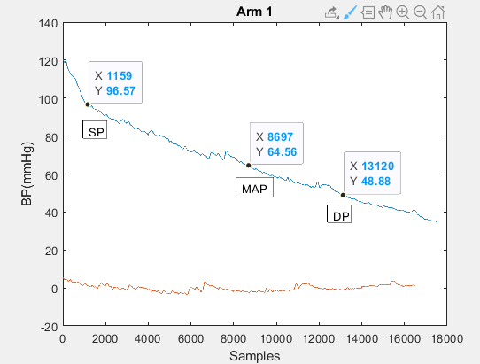

Figure 4. Arm 1

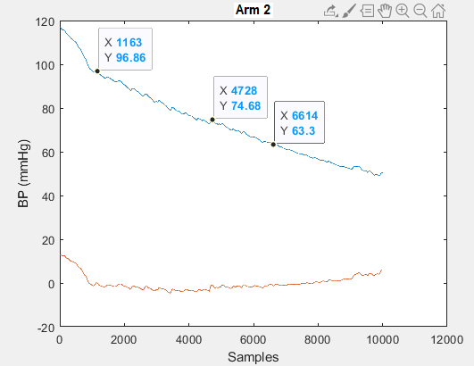

Figure 5. Arm 2

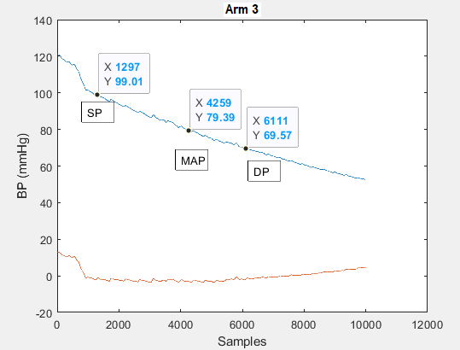

Figure 6. Arm 3

Table 3. Raised Arm Tests

|  | Systolic | MAP | Diastolic |
| --- | --- | --- | --- |
| Trial 1 | 96 | 64 | 48 |
| Trial 2 | 96 | 74 | 63 |
| Trial 3 | 99 | 79 | 69 |
| Average | 97 | 72 | 60 |

**b.** Using the ‘floor’ calculate the average MAP, systolic and diastolic blood pressures for lying down files. Include figures of the blood pressure and label your systolic and diastolic values.

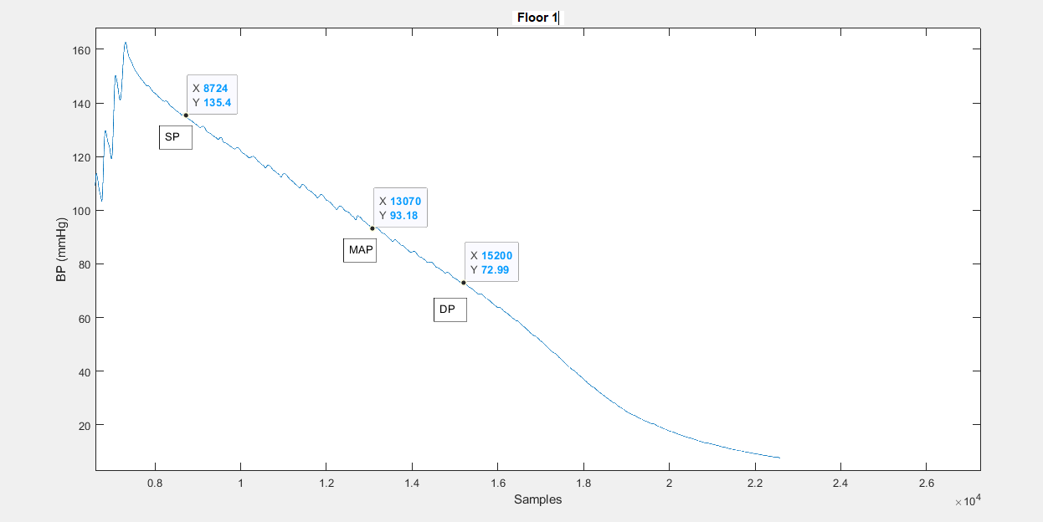

Figure 7. Floor 1

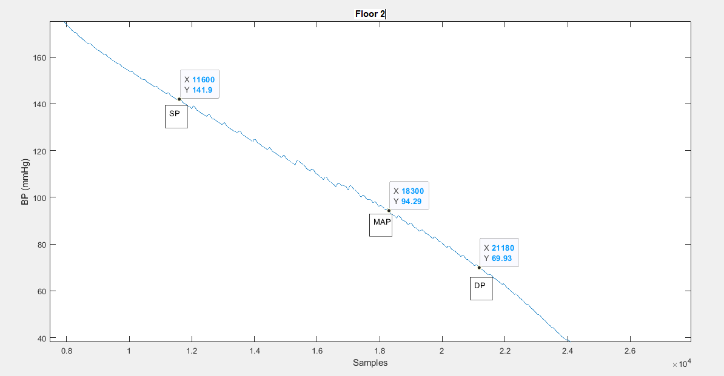

Figure 8. Floor 2

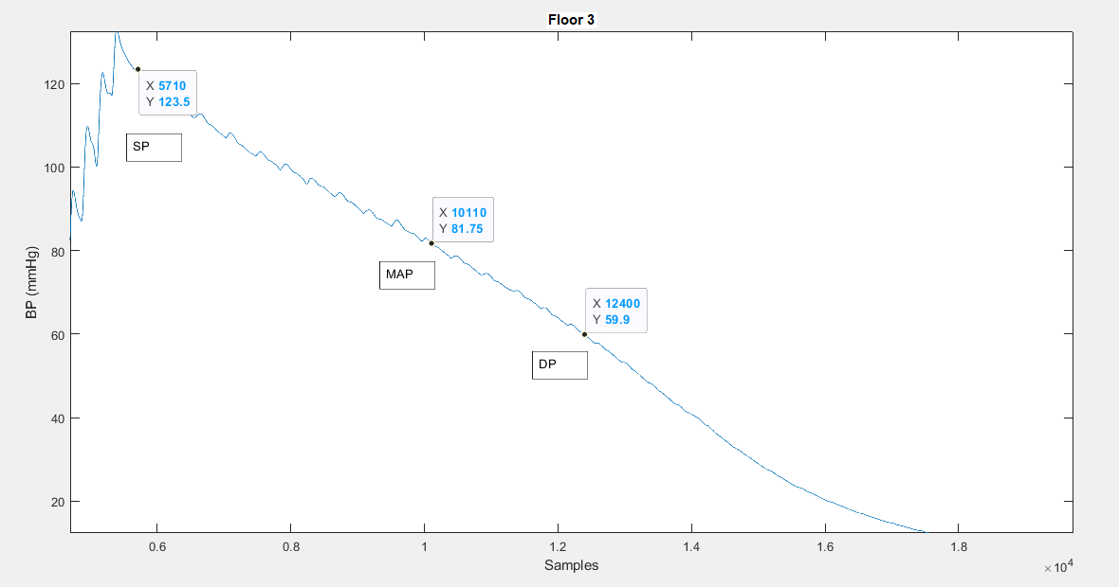

Figure 9. Floor 3

Table 4. Laying on Floor Tests

|  | Systolic | MAP | Diastolic |
| --- | --- | --- | --- |
| Trial 1 | 135 | 93 | 72 |
| Trial 2 | 142 | 94 | 70 |
| Trial 3 | 123 | 81 | 60 |
| Average | 133 | 89 | 67 |

**c.** What if any is the effect of arm position on the blood pressure values you recorded (for ‘relaxed’, ‘arm’, and ‘floor’)? (Use the effect of gravity in Appendix A to clearly explain your results).

(Δ) Arm position is inversely correlated with Blood pressure. This means as the arm position increases ‘up’ the blood pressure will decrease. This is due to the equation ΔP = pgΔh, where P is pressure, p is density, g is gravity, and h is the height of the heart. So by raising your arm, your heart height stays the same. But the density or volume of blood flowing to your hand is less than it was when your arm was relaxed, and oppositely, when lying down, there is an increase in the density of blood flowing. Also, the fact that when the arm is relaxed, blood is flowing in the same direction of gravity, when the arm is raised, blood is flowing in the opposite direction of gravity, meaning g becomes negative. When g becomes negative (raised arm) ΔP also becomes negative, meaning there was a drop in blood pressure. But when lying down, g remains positive and there is an increase in the density of blood flowing so ΔP stays positive but also increased, as compared to ΔP of the relaxed arm.

**d.** If you were upside down, would your MAP increase or decrease? What about your systolic and diastolic pressures? Why? (Use the effect of gravity in Appendix A to clearly explain your results).

I believe that MAP would increase if you were upside down. This is the case as the force of gravity (9.81m/s2) is not opposing the flow of the blood through the arteries. This would also mean that there would be an increase in systolic and diastolic pressures.

**4.0 - Effect of Exercise**

**a.** Calculate the average MAP, systolic and diastolic blood pressures after exercising. Include figures of the blood pressure and label your systolic and diastolic values.

Table 5. After Exercise Tests

|  | Systolic (mmHg) | MAP(mmHg) | Diastolic(mmHg) |
| --- | --- | --- | --- |
| Trial 1 | 92 | 69 | 57 |
| Trial 2 | 125 | 94 | 76 |
| Trial 3 | 115 | 84 | 68.5 |
| Average | 110 | 82 | 67 |

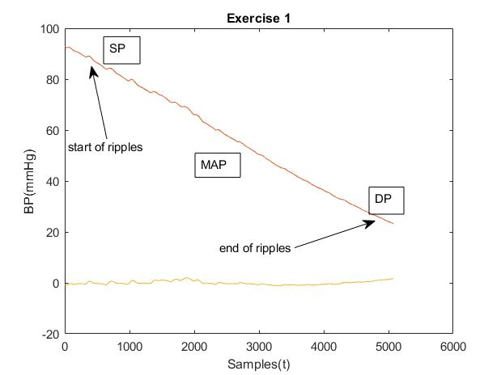

Figure 10. Exercise 1

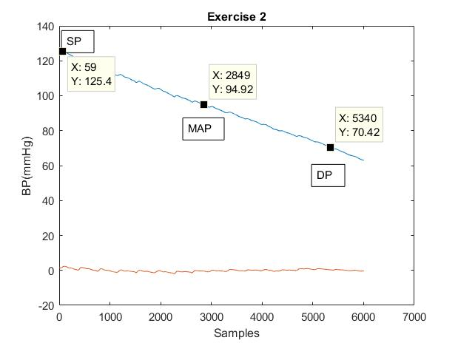

Figure 11. Exercise 2

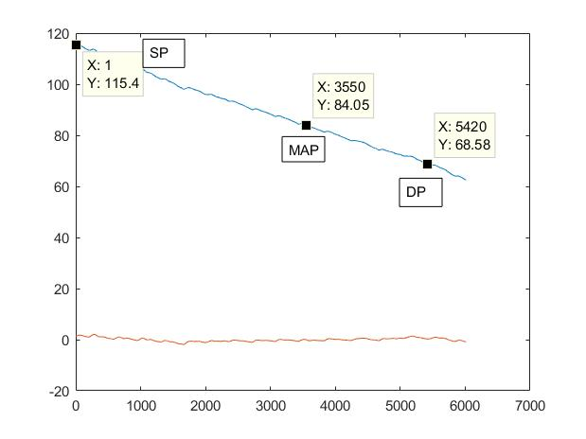

Figure 12. Exercise 3

**b.** What is your average heart rate (in beats per minute) for each file? (Use the first and last 5-10 beats).

Table 6. Average Heart Rate for the after Exercise Tests

|  | Heart Rate (BPM) |
| --- | --- |
| Trial 1 | 114.50 |
| Trial 2 | 91.29 |
| Trial 3 | 91.10 |
| Average | 98.96 |

**c.** What is the effect of exercise on your blood pressure? Why?

Exercises increases overall blood pressure. During the exercise the body requires far more oxygen than when it is at rest. To cope with this increase, the heart must pump faster to provide the required amount of oxygen. The faster the heart pumps the greater the overall blood pressure becomes.

**Appendix**

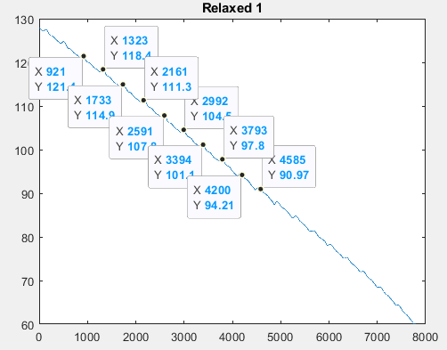

Figure 13. Relaxed 1 middle ten beats

1. Convert x values of first beat and last beat to seconds (500 Hz sample rate)

921/500 = 1.842 s

1323/500 = 2.646 s

1733/500 = 3.466 s

2161/500 = 4.322 s

2591/500 = 5.182 s

2992/500 = 5.984 s

3394/500 = 6.788 s

3793/500 = 7.586 s

4200/500 = 8.400 s

4585/500 = 9.170 s

1. Calculate time interval where 10 beats took place

9.170 s - 1.842 s = 7.328 s

1. Convert from 10 beats/7.328 seconds to beats per second

10beats/7.328s = 1.360 BPS

1. Convert BPS to BPM

1.360 beats / s * 60 s / min = 81.87 BPM